Remembrance of the Lives Lost on Key Bridge
On March 26th, 2024, the Francis Scott Key bridge collapsed after being struck by a cargo ship. In its wake, six individuals have been lost, leaving families gripped by anguish and uncertainty as first responders attempt to recover the bodies of their loved ones.Mayor Scott and MIMA have been in contact with the victims’ loved ones. Families have been provided multi-agency briefings on the status of recovery efforts and support resources available to them.In light of this tragic loss of life, MIMA has activated a donation account to support the victims’ families and survivors during this difficult time. The money raised will be distributed to those impacted based on immediate and ongoing needs. While monetary support can never replace the loss of a loved one, our goal is to help ease the burden of those affected by this tragedy. For more information on how to donate, visit bit.ly/DonateToKeyBridgeFamilies

In addition, following the incident, families have been assigned case management support through an immigrant non-profit organization, which has proven instrumental in guiding them through the labyrinth of available services and resources tailored to their unique linguistic needs. This dedicated assistance not only overcomes the communication gap but also ensures that families receive the appropriate aid. The compassionate and culturally sensitive approach of the organization's case managers fosters trust and understanding, empowering families to rebuild their lives with dignity and resilience amidst this difficult time.

MIMA is thankful to all the number of organizations (public and non-profits) working around the clock to support these families.

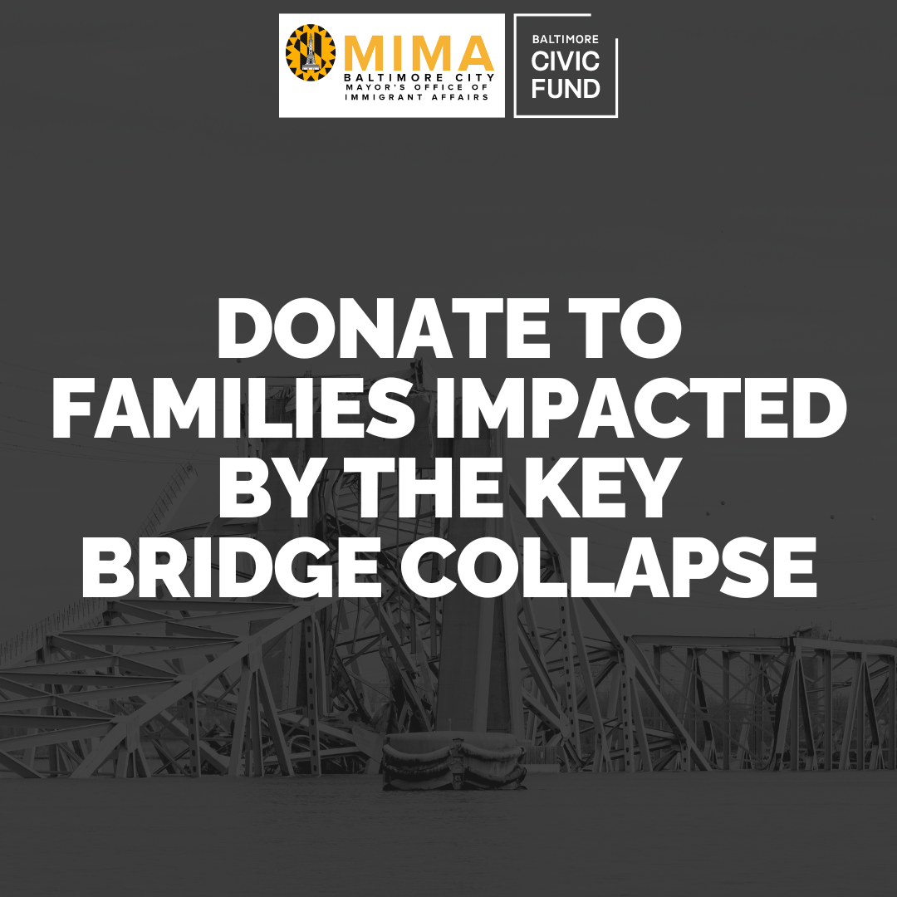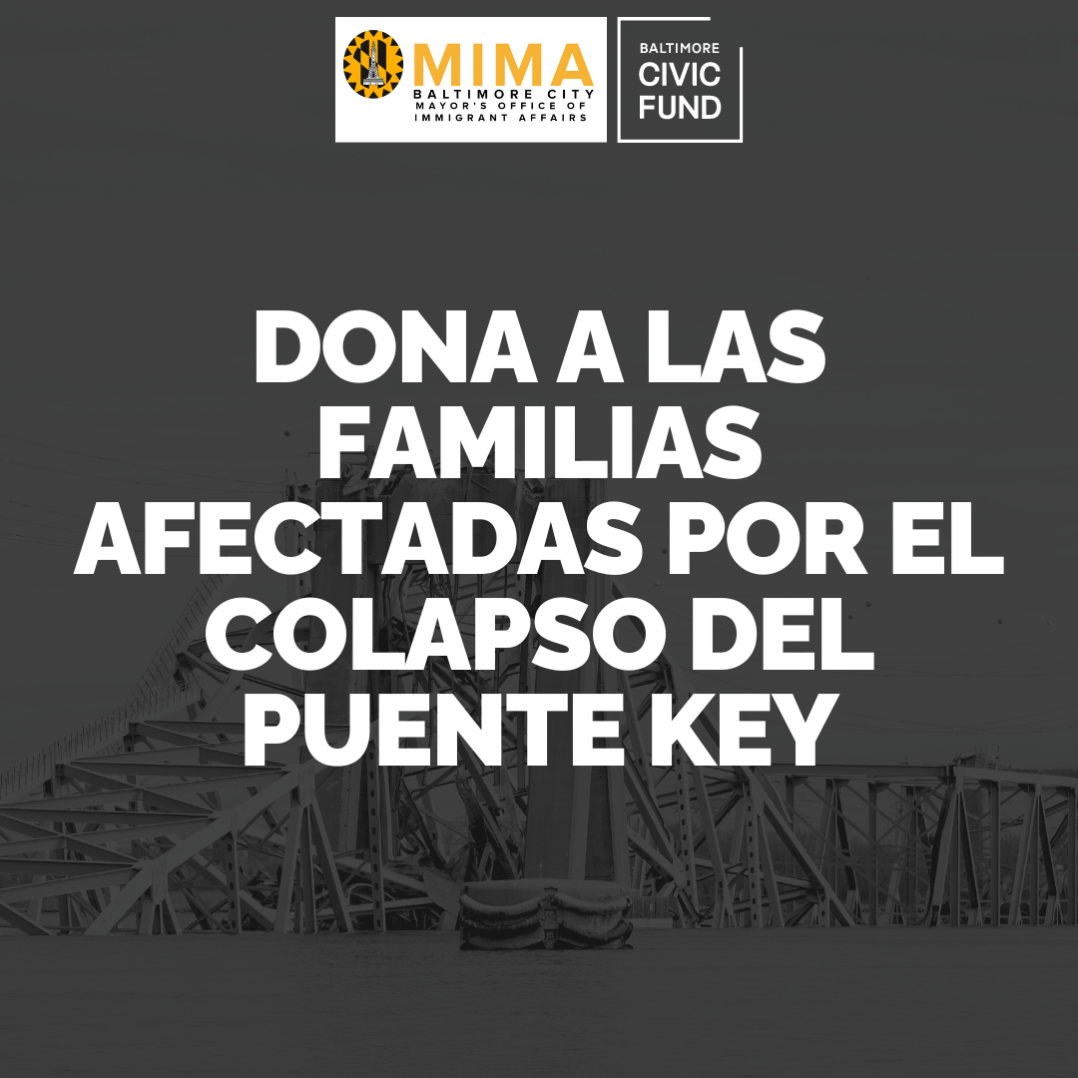

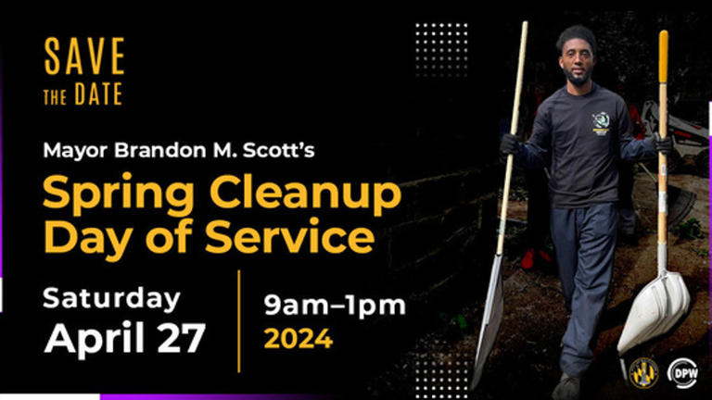

Earth Day
Plant a tree or volunteer at your local park this year for Earth Day! Being conscientious of the world and the ability to care for it is essential for a healthy environment. Earth Day is a yearly event that commemorates the accomplishments of the environmental movement and promotes the necessity to preserve Earth's natural resources for future generations. In the United States, Earth Day is celebrated on April 22 or the day of the spring equinox.

Mayor Brandon Scott has announced that the Mayor's Annual Spring Clean-up and Day of Service will be help on April 27th. Residents, volunteer groups, and community associations are invited to register now to participate in this city-wide initiative to enhance the beauty of neighborhoods.To volunteer at a predetermined location, please visit mayor.baltimorecity.gov/annual-spring-cleanup.

Date: April 27th
Time: 9 a.m. to 1 p.m.

Tax Day
Attention all taxpayers! Have you marked your calendars for the upcoming tax filing deadline? The deadline to file your federal tax return, pay any tax owed, or request an extension to file is April 15, 2024. Remember, the IRS has Saturday assistance with questions or concerns. More info can be found at: IRS Face-to-Face Saturday Help.

Happy Eid al Fitr
As the end of Ramadan approaches, anticipation sets in for the celebration of Eid Al-Fitr. Predicted to begin on April 10, this festive occasion marks the end of the holy month and is one of the most significant holidays for Muslims around the world. During this time, individuals come together in prayer and reflection to commemorate the completion of the month-long fast.

Happy Passover

Chag Pesach Sameach!April 22nd marks a very important holiday for those who practice Judaism.Passover, also known as Pesach, is a springtime Jewish holiday celebrated worldwide. It commemorates the time when the Jewish people were freed from slavery in Egypt. The festival lasts for eight days, during which time, no bread or fermented grain is consumed or owned. The Passover Seder is held on the first two nights. Passover is one of the three pilgrimage festivals that celebrate the Biblical story of the Israelites' escape from slavery in Egypt.

Updates from our Office
New MIMA Staff: Please help us welcome Agatha and Natalie!
Language Access Project Manager: Agatha So
In her role, Agatha will assist City agencies with language access, specifically as they design and implement relief programs and resources for City residents. She will support city agencies with translation of vital documents, access to telephonic interpretation services, and training frontline staff members on working with LEP individuals.
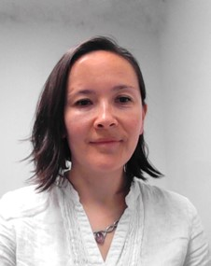
Before joining MIMA, Agatha worked as professional staff on the House Financial Services Committee, for Congresswoman Maxine Waters, developing policies that promote financial inclusion for communities across the nation, including communities historically underserved in the financial services system. Prior to that, she spent several years working to promote language access in the mortgage market nationwide, ensure Latino immigrant families in Baltimore City have access to the dream of homeownership, and connect immigrant communities with resources and services so they can thrive.
Agatha holds a Master of Social Work degree from the University of Maryland. She is proficient in Spanish, and conversational in Mandarin and Polish.

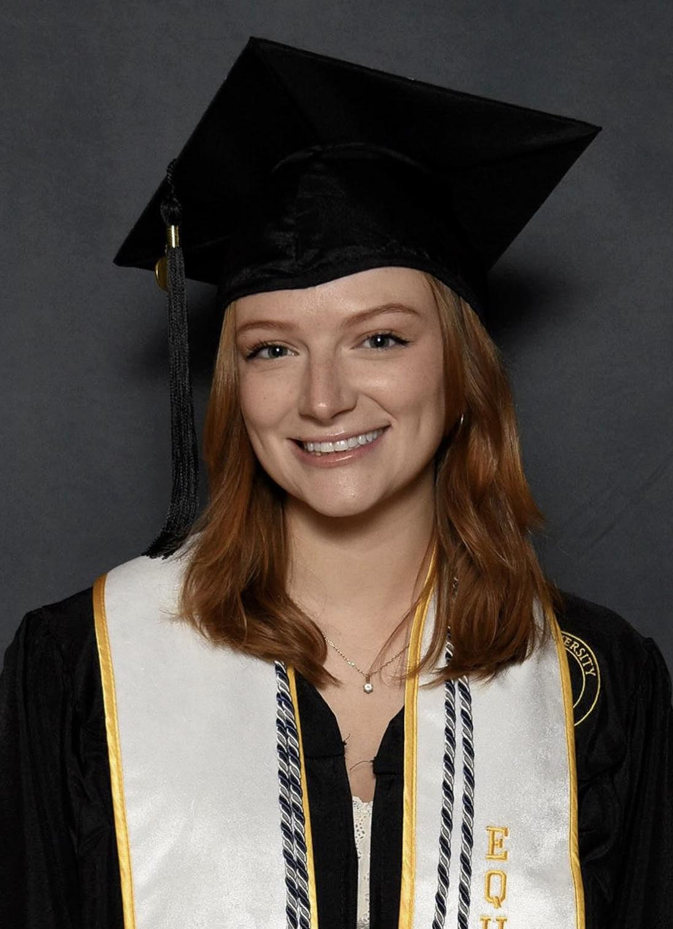
MIMA’s Baltimore Immigration Summit Intern:Natalie Wilard
Recently graduated in December 2023, Natalie received her Bachelor's of Science in Psychology and Fine Arts, along with a minor in International Studies. She has a wide range of interests, but her personal passion is helping underserved populations. With her background of growing up in Madagascar and coming from an immigrant family, she aspires to work as a counselor one day for immigrants and refugees--hoping to help others feel empowered during a time of challenging transitions. Prior to her internship at MIMA, Natalie has worked as a grant writer, research assistant, and an intake coordinator. She is excited to bring her skillset to MIMA, and can't wait to learn more from the MIMA team and to be part of an incredible mission.

11th Baltimore Immigration Summit-SOLD OUT
The Baltimore Immigration Summit is set to take place in two months and MIMA is already at full capacity for this event. We want to thank everyone who registered this year. Last year's summit was a huge success and MIMA is looking forward to achieving the same level of success this year.

Academic Internship Program- Summer Internship
The Academic Internship Program (ACIP) offers a unique opportunity for participants to gain professional experience, build skills through practical application, and obtain educational credits to be applied towards their major/minor at their academic institution. Interns will work on projects that are social-impact focused, and the primary goal of the internship is to offer young professionals interested in public service an opportunity to expand their networks and gain exposure to careers in local government. This is a 12-week, unpaid internship that provides current students and recent graduates with an opportunity to work directly with the Mayor’s Office of Immigrant Affairs and receive academic credits for their academic institution. Summer: June-August (Applications deadline: April 10th)
Mayor Brandon M.Scott’s State of the City-The New Golden Age in Baltimore
“I have always said that I want to be the Mayor who laid the foundation for a new golden age in Baltimore. That has been my promise, and tonight it is easy to see the progress.” Impactful words delivered on March 25th during the 4th State of the City address. The ideology for the new golden age of Baltimore is one of providing "Equity ,transparency, accountability, and integrity".Mayor Brandon Scott stated this has been his core mission for Baltimoreans.Growing up in Baltimore, Mayor Scott understands the need for Baltimore to do better because Baltimoreans deserve better. Reminiscing on his own experience, this commitment to the youth and a bright future for Baltimore is crucial for a better Baltimore. Mayor Scott ensured that Baltimore will have a bright future ahead by fueling a government that wants the best for its people. To read more about the mayor's speech click here.

Covid-19 Updates

When are You Up to Date With Vaccinations?

For people aged 5-64 years, getting a single updated COVID-19 vaccine dose is enough to be considered up-to-date. For children aged 6 months to 4 years, they are considered up-to-date when they receive all the recommended doses, including at least one dose of the updated COVID-19 vaccine. For people aged 65 years and older, receiving two updated 2023-2024 COVID-19 vaccine doses is necessary to be considered up-to-date. For more information about the recommended doses of Covid-19 vaccinations visit: Stay Up to Date with COVID-19 Vaccines | CDC. The CDC also provides updated analytical data through the Covid Data Tracker.

City Services
Baltimore City 3-1-1
311 connects Baltimore citizens, businesses & visitors with a vast array of city services, programs and information. Either by a live agent-assisted phone call or through the self-service web or mobile portal, 311 allows customers to report a problem, request a service, check the status of a previously submitted service request, to request fire alarm installation, and obtain information regarding City programs or events. This month 3-1-1 will also be available in Spanish and other languages will be available in the future.

Water4all-Department of Public Works

Water4All provides financial assistance for water and sewer bills. The water rates are based on a percentage of your income. Eligibility is open to Baltimore City residents earning less than 200% of the federal poverty level guidelines, or $55,500 a year for a four-member household. Apply now to get a monthly discount or call 410-396-5555.

Recycled PC Devices-Baltimore City Information & Technology
Along with providing digital resources, Baltimore City Information & Technology also recycles used electronics. If you have used or retired electronics, BCIT is interested in recycling your donations to help low income families. Click to learn how your devices can be of help to families,individuals, and non profits in need.

The Baltimore New American Access Coalition-Advancing with Resources
The Baltimore New American Access Coalition (BNAAC) is a group of community organizations [CASA, Esperanza Center, Southeast CDC, Global Refuge, led by MIMA, who are offering public benefit navigation to immigrant families in Baltimore. Eligible clients can receive help with applying for public benefits, including, health care coverage, Supplemental Nutrition Assistance Program (SNAP), Women, Infants and Children (WIC), Temporary Cash Assistance (TCA), childcare, water for all, and more. Since its inception, the BNAAC program has enrolled 577 clients from 23 different Baltimore City zip codes. Benefit Navigators aided in filling out 1340 public benefit applications. The program is currently providing benefit navigation support in over 13 languages.
- Global Refuge is now taking clients!
  - Interested clients can call, text, or WhatsApp message 443-365-0472
- For more information about the program, and eligibility, and to see our translated flyers visit our website.
- To refer a client to the program, use the following form.

What’s New This Month?
Maryland Department of Housing and Community Development
MDHCD promotes and preserves homeownership through community development initiatives to meet the challenges of a growing Maryland. Through the Maryland Mortgage Program, the department has empowered thousands of Maryland families to realize the American dream of homeownership. To find out more information about the program and financing solutions that help families, communities, and businesses.

2024 Resource Fair-Baltimore Connect
Rain or shine Baltimore Connect will hold a community event providing free health resources,free health screening,free food, and giveaways.To register contact Baltimoreconnectinc@gmail.com.

- Date: April 13th
- Location: 2556 Druid Hill Ave
- Time:12:00 p.m.-4:00 p.m.

Medicaid Renewal-Cool & Associates in Partnership with Communities Connected
Last year, the State of Maryland began reviewing Medicaid edibility again for renewals. This review process will take place until April 2024. Many Latinos and Spanish-speakers may be impacted if they do not have updated contact information on file. All Marylanders on Medicaid insurance need to make sure their contact information is up to date. They can do so by logging into their account at Maryland Health Connection, calling 855-642-8572, or visiting their local Department of Social Services or local Health Department. This will ensure they will receive a renewal notice.

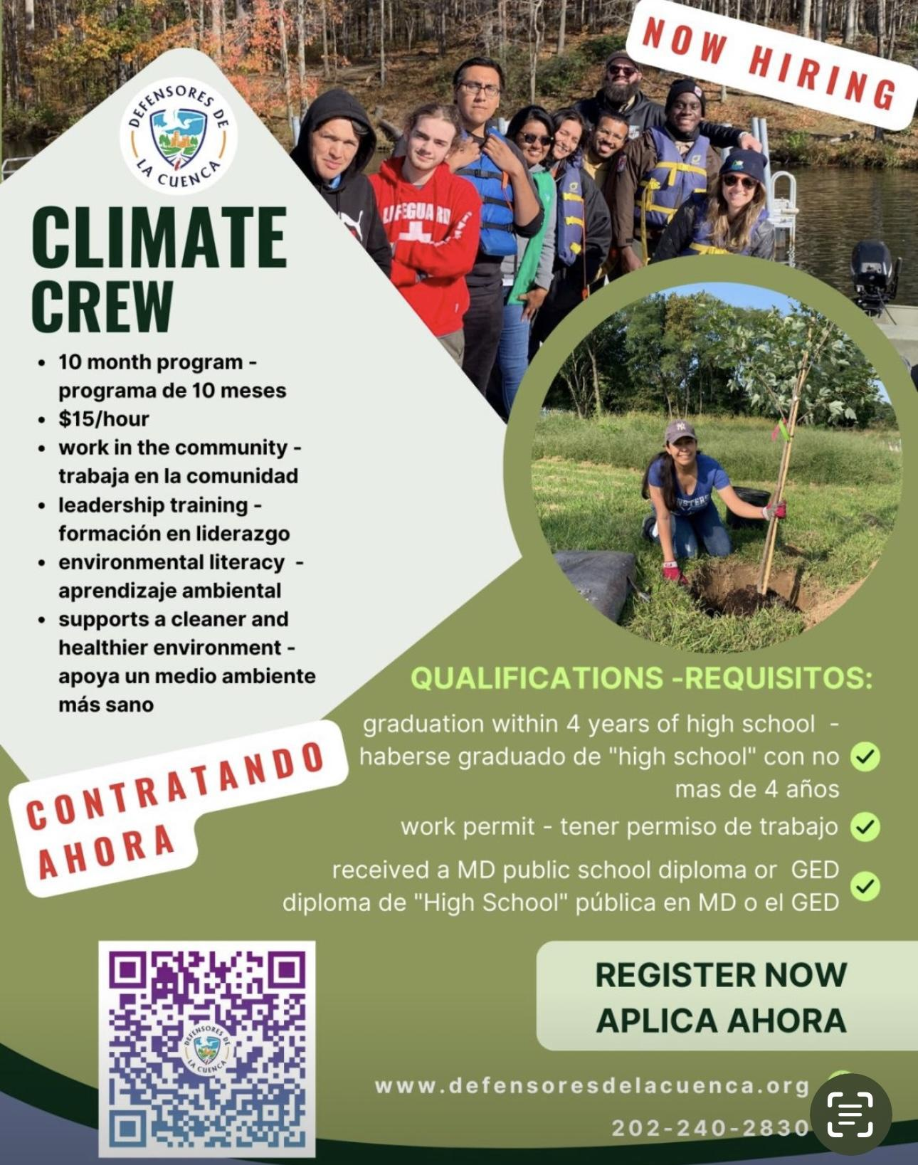
Climate Crew Job Opening-Defensores De La Cuenca
This 10 month leadership training is geared to work in the community and provide environmental literacy for a cleaner and healthier environment. This is a paid position for those looking to gain information about working in the community and learning various leadership skills.To register for this event please visit: www.defensoresdelacuenca.org.

The Partners for Children’s Health Project-University of MD.
Great opportunity for Latina mothers of infants. The Partners for Children Health Project is helping mothers with a 10-week home visiting program to be trained by an expert in infant development.Toys and activities will be provided. Mothers and their infants also complete research activities.

Mothers with infants 6-14 months old that are patients of BMS at Yard 56 are eligible and can call to register: 443-863-8040 ask to speak with Ms. Nayely or 443-948-6463 to speak withMrs. Fiorella.

Grant/Scholarship Opportunities
Mayor’s Scholars Program-Baltimore City Community College
Earn an associate degree or complete a workforce training program tuition-free. Baltimore City Community College is making college affordable through a last-dollar scholarship with the Mayor’s Scholars Program (MSP). This opportunity makes college and job training programs affordable and helps students move toward a rewarding career and financial security. Email msp@bccc.edu to learn more about free tuition through the Mayor’s Scholar Program.

College Completion Program-College Bound Foundation
The College Completion Program offers a Last Dollar Grant or Book Award. These are need-based awards for Baltimore City public high school graduates whose expected family contribution and financial aid package total less than the cost to attend college. Students who are awarded a CollegeBound Foundation Last Dollar Grant are eligible to receive a renewable grant of up to $3,000 per year. These Grants are gift money that does not have to be repaid.To have been considered for the College Completion Program, applications must be submitted by June 1st, 2024.

College Completion Program Eligibility:
• Must be a 2024 graduate of a Baltimore City public high school.
• Applicants must demonstrate financial need and be eligible to receive a Pell Grant or MSFAA
• If unmet need is more than $3,000 from billed expenses, student must provide documentation detailing how the gap will be financed.
• Be accepted to and attend a four-year college/university.
Gates Milleneum Scholars Program-Maryland.Gov
The Gates Millenium Scholars (GMS) Program, funded by a grant from the Bill & Melinda Gates Foundation, was established in 1999 to provide outstanding African American, American Indian/Alaska Native, Asian Pacific Islander American, and Hispanic American students with an opportunity to complete an undergraduate college education in any discipline area of interest.
Howard P. Rawlings Campus Based Educational Assistance Grant- Maryland.Gov
The Howard P. Rawlings​ Campus Based Educational Assistance Grant (CBEAG) program is a need-based financial aid program that is designed to financially assist students that were not considered for the Howard P. Rawlings Educational Assistance Grant due to not filing their Free Application for Federal Student Aid (FAFSA) or Maryland State Financial Aid Application (MSFAA) by the Maryland state deadline of March 1st. The CBEAG program is a state funded program which allocates funds to participating institutions each academic year to select and award students that are qualified for the CBEAG award.

EVENTS
Fresh Food Boxes-Baltimore City Department of Recreation and Parks
Don't miss the opportunity to get fresh food boxes for free every Thursday from 12 pm to 4 pm! BCRP is inviting you and your friends to the Plantation Park Heights Urban Farm, located at 3811 Park Heights Ave. This event is open to everyone. Mark your calendars and be sure to check out the event calendar for upcoming BCRP fresh food events!

Familias Reunidas-Global Refuge
Gain an understanding of the difficulties that immigrant families face when relocating to the United States. Familias Reunidas is a four-session workshop designed to support Spanish-speaking families who have undergone separation and reunification during the migration process. This program aims to provide families with the necessary tools and resources to overcome obstacles and strengthen their relationships. Through this program, families:
- Will gain a deeper understanding of the emotions experienced by both caregivers and children throughout the reunification process.
- They will learn strategies to improve their relationships, and caregivers will gain insight into their children’s feelings, understand why certain decisions were made, and learn how to initiate difficult conversations.
- By participating in this program, families can build a strong foundation for a successful future together.

Join this workshop and take the first steps in learning about the reunification process.

- Dates: April 25,May 2,9, and 16th
- Time: 6:30-8 pm
- Location: online via Zoom

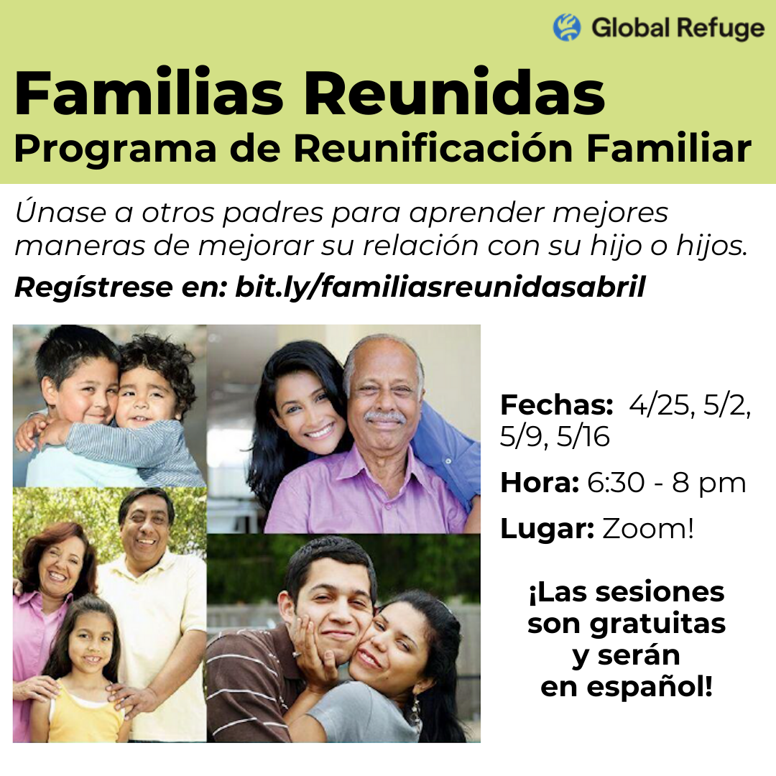

Earth Day Celebration- Carefirst Engagement Center
Join CareFirst Engagement Center to celebrate Earth Day. Clean up THE community and celebrate our planet. After the cleanup, lunch will be provided and guest speakers will talk about the importance of a clean environment. Let's make a difference and have a great time doing it! Service hours can be provided for this activity. This is a Free community event. Register for a cleaner Baltimore.

“Good Deeds Day” Spring Clean Up- CHAI and Norwest Baltimore Partnership
Join CHAI for a community clean up of Western Run stream on Good Deeds Day!Volunteers will gather at Cross Country Elementary School beginning at 1pm to pick up supplies, receive instructions, and meet representatives of local neighborhood associations and organizations.The cleanup will take place along the stream from 2pm-4pm.Volunteers of all ages are invited!
Summer Camps-BCRP
The end of the school year is swiftly approaching. Camp Baltimore, B’More Summer Fun and a variety of Specialty Camps will be offering summer activities at sites all across Baltimore. For eight weeks children will enjoy fun-filled activities. Explore all camp location and registration
Spring Pickleball for Seniors – BCRP
BCRP’s Senior Division is hosting a pickleball tournament for seniors 50 and older on April 18 and 19 at Middle Branch Fitness and Wellness Center. We are also offering pickleball classes for seniors 50 and older. Classes are taught by a certified pickleball instructor. Click here for more information!

Ready, Set, Hire Career Fair-BCRP
Looking for a new job? Join the Rec & Parks team! Ready, Set, Hire is their annual employment event where applicants can be interviewed and hired on the spot. Come and meet BCRP at the Rita Church Community Center.
- Date: April 13 from 10am-2pm
- Location: Rita Church Community Center at 2101 St Lo Drive, 21213

Hands on Holidays:Passover-Enoch Pratt Library
Celebrate the Jewish holiday of Passover with the JCC and the Enoch Pratt Free Library! Join Enoch Pratt for a fun celebration! This special program will include storytime, songs, and a special holiday craft. All are welcome!

- April 20, 11:00 a.m., Enoch Pratt Free Library – Light Street Branch
- April 21, 11:00 a.m., Enoch Pratt Free Library – Hampden Branch

Don’t Miss April 15th Tax Deadline-Cash Campaign
The CASH Campaign of Maryland (Creating Assets, Savings and Hope) is a nonprofit organization that assists in preparing tax returns. Individuals or families with a household income of $64,000 or below can schedule an appointment. For an appointment with tax preparation or financial literacy education click here or call 410-234-8008.

National Happenings
USCIS Streamlines Process for Refugee Employment Authorization Documents-U.S. Citizenship and Immigration Services
The United States Citizenship and Immigration Services (USCIS) has started implementing a more efficient process for issuing Employment Authorization Documents (EADs) to eligible refugees who have been admitted into the United States. This new process aims to shorten the waiting time for an EAD from several months to approximately 30 days. All refugees who are admitted into the country on or after December 10, 2023, will receive EADs under this new streamlined process. According to U.S. law, refugees are authorized to work as soon as they arrive in the United States. This new automated process eliminates the need for refugees to apply for an EAD, resulting in faster processing and adjudication of Form I-765, and quicker delivery of EADs after they are approved. this new process. Under U.S. law, a refugee is legally authorized to work as soon as they arrive in the United States. The efficacy of this new process allows for a quicker delivery of EADs.

EMPLOYMENT OPPORTUNITIES
Mobile Career Navigator, Mayor’s Office of Employment Development

Various Openings, Johns Hopkins Medicine

Customer Accounts Manager, Department of Public Works

Emergency Services Associate, Mayor’s Office of Homeless Services

CDL Driver II,Mechanical Street Sweeper, Department of Public Works

Basketball Coach, Islamic Leadership Institute

Teacher (Eastern Region), State of Maryland

Environmental Sanitarian II, Health Department

Front Desk Assistant, World Relief

Operations Aid, Baltimore City Convention Center

Special Assistant to the Commissioner of Health,Grant Service Specialist III-Health Department

Emergency Dispatcher, Baltimore Police Department

Bilingual Program Supervisor, Mayor’s Office of Employment Development

Bilingual Career Coach, Blueprint, Grant Service Specialist II,MOED

Bilingual Clinical Assistant,Grant Services Specialist I,Health Department

Bilingual Program Supervisor Blueprint, Mayor’s Office of Employment Development

Want to stay updated with the latest information and resources for our immigrant and refugee communities?

Follow MIMA on Facebook and Instagram!

To sign up to receive our monthly update via email or suggest announcements to include, please submit this form.

