Celebrate Asian American and Pacific Islander Heritage Month

Happy Asian American and Pacific Islander (AAPI) Heritage Month! We encourage all Baltimoreans to take time this month to consider the role of Asian, Asian Americans, and Pacific Islanders in our histories, as well as the continued role they have in our communities’ futures. Baltimore’s AAPI community members have been and continue to be artists, advocates, city leaders, healthcare professionals, business owners, and much more. We hope you have a great Asian American & Pacific Islander Heritage Month! Look at the events section to see some of the celebrations happening this month.

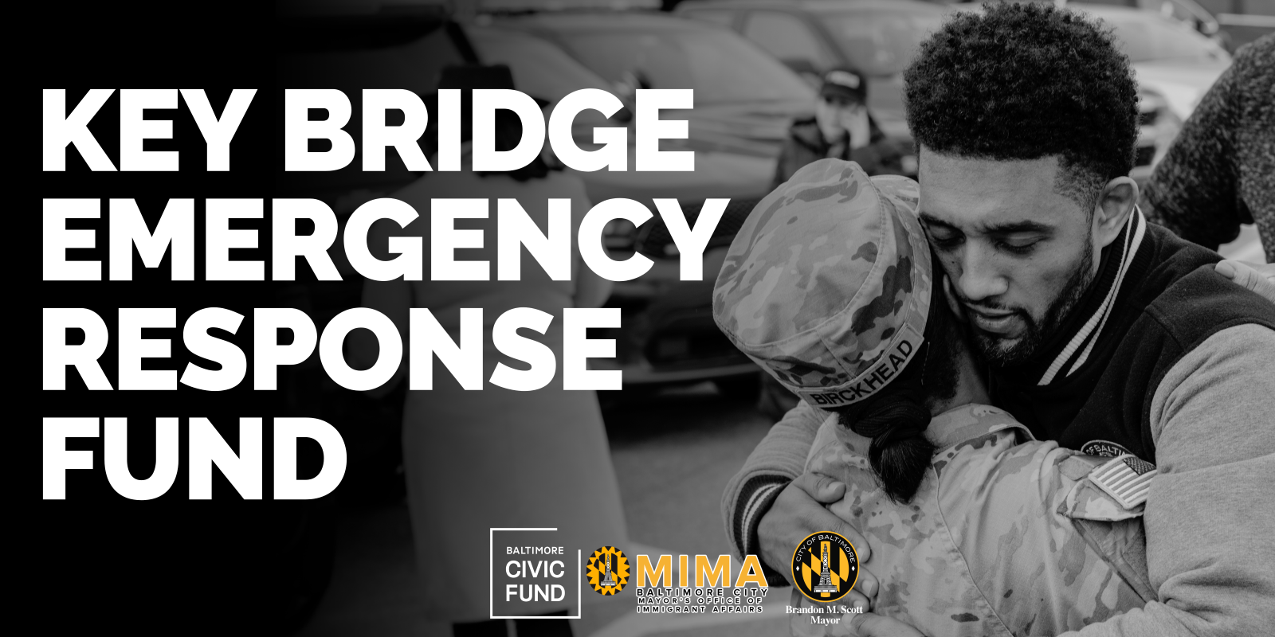

Key Bridge Emergency Response Fund Update

Shortly after the Key Bridge’s collapse on March 26, the Mayor’s Office of Immigrant Affairs (MIMA) organized the Key Bridge Emergency Response fund through the Baltimore Civic Fund. The primary objective of this fund is to alleviate the financial burden faced by the survivors and victims’ families. The fund has received overwhelming support, on Friday, May 3, the fund had received 5,469 donations and raised $787,382.33. Thank you for generosity and support to these families during this difficult time. As of April 18, funds have started reaching families to cover basic needs (rent, food, utilities, childcare, remittances, etc.). MIMA and the Civic Fund will continue to assist these families until funds are exhausted. Please see a breakdown of what these funds have been used for in the graph below.
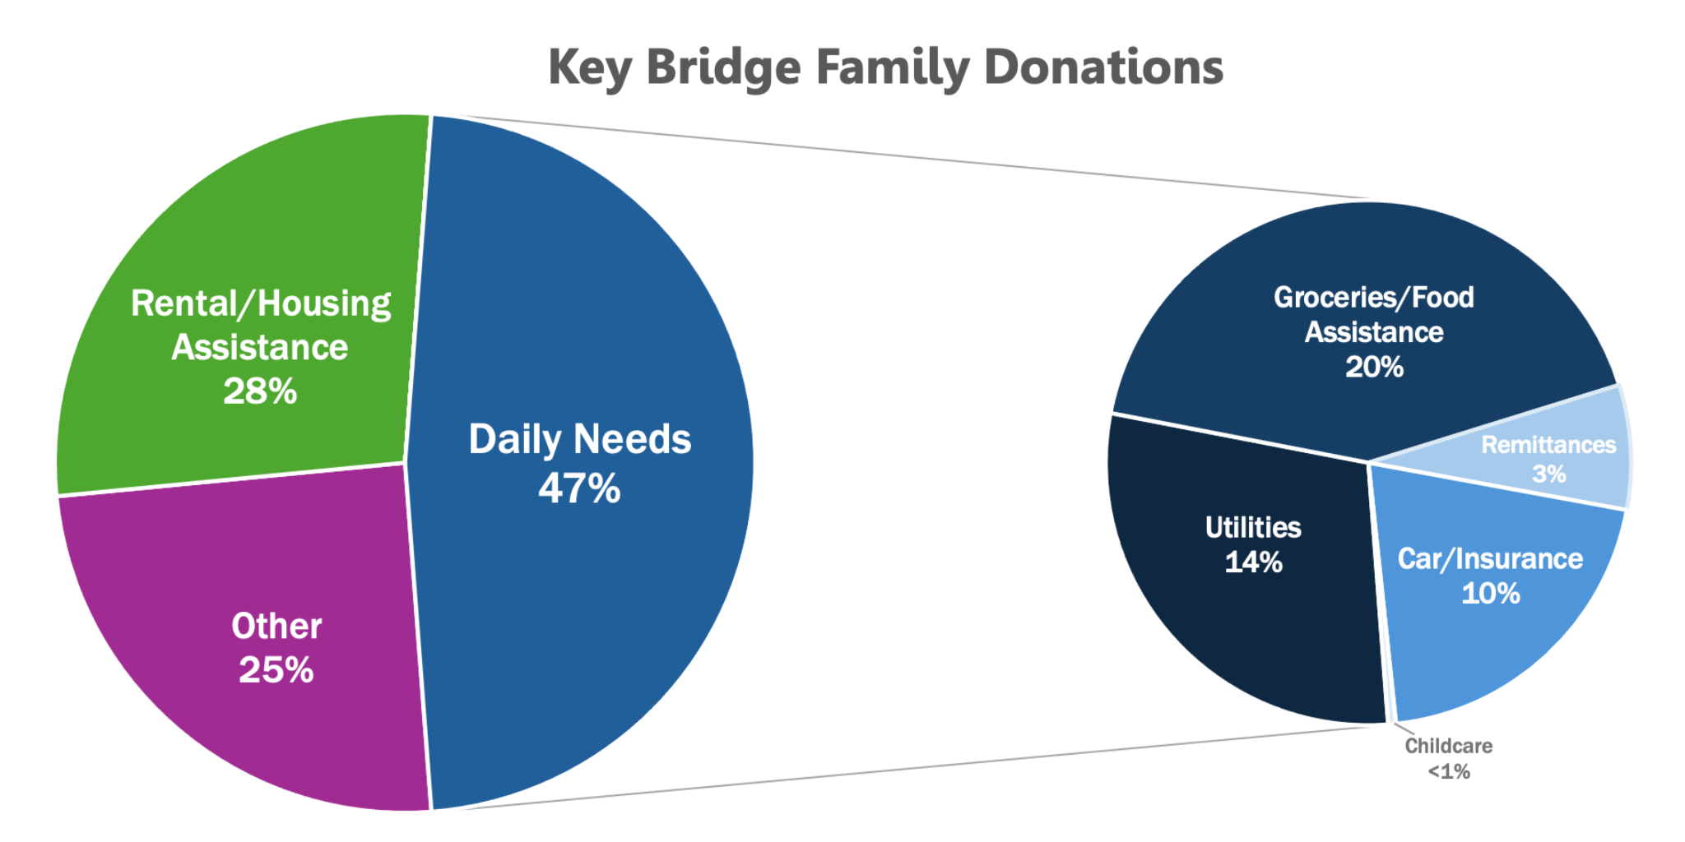

Thank You!

MIMA and the Civic Fund want to recognize the 5,469 donors who have gone above and beyond to support those who have been impacted by the tragedy. These donors have exemplified the meaning behind “Baltimore Strong” showing their commitment and care for their neighbors during this time of hardship and grief. Below we have listed the individuals and groups who donated more than $1,000 before May 1 and who have consented in having their name shared with the public. We thank you for your generosity and support!

$1000 - $4999

Annie Demczak
Maria Anderson
Woo-suk Yang
George Korphage
Deight Chandler
Dutch Courage
Michelle Pratt
Magan Ruthke
Dwight Bartholomew
Barbara Stiefel
James Chapman
Matthew Vieyra
Cecil Flamer
Timothy Soncrant
Peter Keisler
Asuncion Martinez
Linda Foreman
Nancy Codori
Louis Christopher
Jennifer Molina
$5000 - $9999

Marc Dixon
Cape Foundation of Maryland
Index Analytic
Oriole Advocates Charitable Foundation, Inc.
NOVA Catholic Community
$10000 - $2499
James & Joyce Giles Foundation
Clayton Baker Trust
$25000 or more
Maryland Brand Management
Constellation
Comcast
Puppie Love

If you are interested in donating, please visit the Baltimore Civic Fund website. The Key Bridge Emergency Response Fund will remain open to accept donations until May 31, 2024. MIMA and the Civic Fund are committed to providing monthly updates to stakeholders, donors, and the wider community on the use of the funds.

Key Bridge Resources
As response to the collapse of the Key Bridge continues, we are sharing resources for those that may be impacted.
For the most up to date reports and a list of resources, please visit: https://emergency.baltimorecity.gov/francis-scott-key-bridge-collapse-updates
For additional updates about the Mayor’s Office’s response to this ongoing issue, please also visit the Mayor’s press release page: https://mayor.baltimorecity.gov/news
Please also note that, from time to time, information in languages besides English may differ slightly from information provided in English, considering the time necessary to develop the translations.
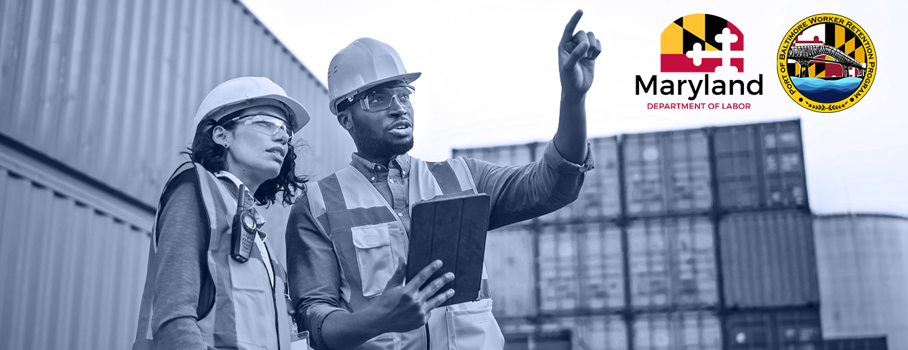
Port of Baltimore Worker Retention Program
As part of Governor Moore's response to the economic impact caused by the recent collapse of the Francis Scott Key Bridge, Maryland’s Department of Labor has established the Port of Baltimore Worker Retention Program. The Worker Retention Program can provide up to $200,000 in grant funding to pay for employee wages (up to $7,500 per worker) to keep workers on the job and avert layoffs, as well as subsidize supportive services for workers such as childcare and transportation. Eligible applicants are Maryland-based businesses that employ up to 500 workers, labor unions, trade associations, or other organizations whose business activities are hindered or halted entirely due to reduced Port operations. Application materials are available in both Spanish and English. Apply on the Maryland Department of Labor website.

Port Business Wage Subsidy
The Port Business Wage Subsidy Program (POWSP) will award grants to eligible businesses directly impacted by the reduced operations at the Port of Baltimore. The purpose of the program is to minimize or eliminate the need for layoffs by enabling businesses to retain their employees until the Port fully reopens. Grants do not need to be repaid but must adhere to the eligible cost provisions detailed in these terms and conditions. Grants opened on April 15th and will remain open until all funds are disbursed.
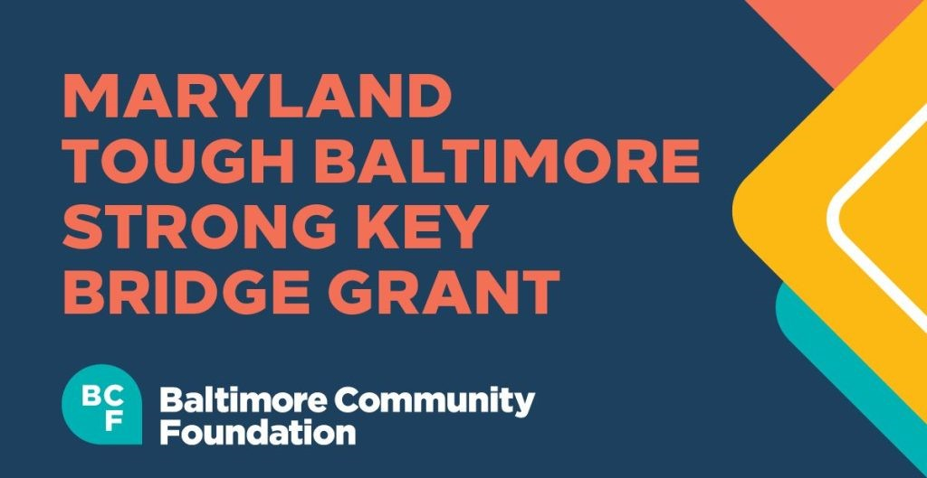

Maryland Tough Baltimore Strong Key Bridge Fund & Grant
The Maryland Tough Baltimore Strong Key Bridge Fund provides a secure way for Baltimoreans and those who care for them to contribute to the recovery and resilience of Baltimore as a result of the March 26th Key Bridge tragedy. Visit the Baltimore Community Foundation Key Bridge Emergency Fund for more information or to make a donation.
The Baltimore Community Foundation is also making grant available for organization that support port workers and their families, first responders and their families, and the surrounding community who may face effects of the Bridge collapse. Find more information or apply for a grant on their website.

2024 Primary Elections

Are you planning on voting in the Presidential Primary Elections in Maryland? There are some essential resources you should know before you go. The Presidential Primary Election Day and the polls will open on May 14, 2024, from 7 am to 8 pm. To vote in person on election days, you must vote at your assigned polling place. All of the early voting centers in Maryland are accessible to voters with disabilities. If you want to learn more about voting, you can find additional information on the Baltimore City Board of Elections website.

Updates from our Office
MIMA Bill 23-0438 Update
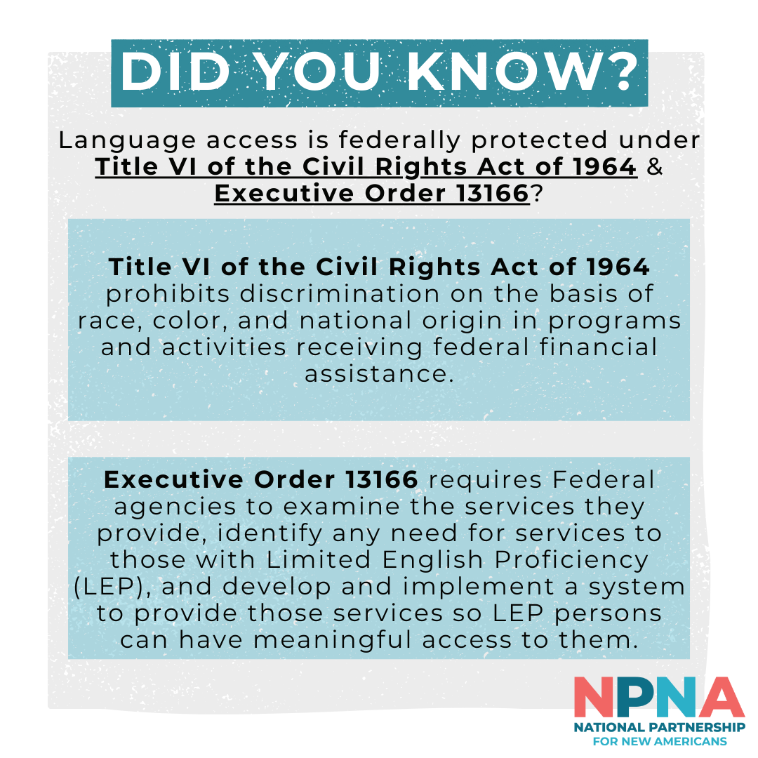
On May 1st, MIMA's codification bill, Bill 23-0438, went through Third Reading and was passed by City Council. As of May 1, the Bill has been sent to Mayor Scott. Once signed, the bill will officially establish the Mayor's Office of Immigrant Affairs (MIMA). Thank you to all our community partners who have attended hearings, spoke on our behalf, and continued to support us. This wouldn't have been possible with you.You can continue to follow the progress of this bill on the Baltimore City Council legislation website.

Baltimore City’s Language Policy Takes Effect
April marked Language Access Month, a time to celebrate the power of communication, inclusivity and diversity. This celebration coincided with significant developments in our city’s commitment to provide greater access and participation for our non-English speaking residents or those with limited English proficiency (LEP). In April, MIMA started its work to implement Baltimore City’s new language access policy, issued by Baltimore City’s Chief Administrative Officer, which took effect on April 1, 2024. The policy directs City agencies providing direct services or emergency information to the public to comply with language access requirements under federal law, including Title VI of the Civil Rights Act of 1964, and the Title VI regulations, prohibiting discrimination based on national origin, and Executive Order 13166 issued in 2000. The policy is modeled from language access policies and laws developed by other local governments across the country. In practice, this policy requires City agencies to ensure they are providing meaningful access, to their respective programs and services, to LEP City residents. In the coming months MIMA will be providing technical assistance to city agencies to develop and implement their own comprehensive language access plans.
Mayor Brandon M. Scott Releases- “Downtown RISE Strategic Action Plan”
“Baltimore is a city of neighborhoods, and for our neighborhoods to be strong, our downtown core must be strong too,” said Mayor Brandon M. Scott. Mayor Brandon collaborated with residents, business owners, and nonprofit leaders to formulate a comprehensive plan that aims to enhance the liveliness of downtown Baltimore.

COVID-19 Updates
An updated version of the COVID-19 vaccinations is available to anyone older than 6 months of age. The updated vaccine offers the best protection against the current, most contagious strain of the virus. Vaccinations are covered by health insurance and available for those without health insurance through special programs for children and adults. Use this link to find a vaccination site near you.
- If you do not have health insurance, you can receive a free vaccine at any local CVS or Walgreens Pharmacy using the Bridge Access Program.
- If you or a family member live in Baltimore City and are not able to leave your home for the vaccination, call (443)-984-8650 to schedule an in-home vaccination appointment
- The CDC provides information on the most recent recommended vaccinations in over 65 languages on their website. For more information on how to get vaccinated in Baltimore City, please visit the Baltimore City Health Department. If you need a vaccination at home please schedule online or call 443-984-8650.

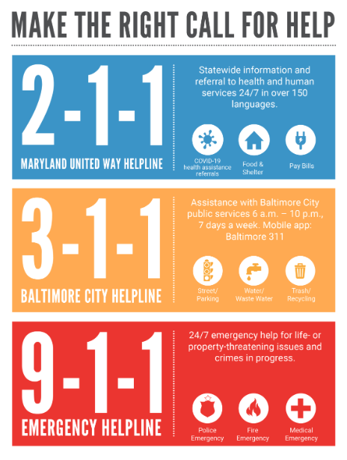

City Services
Baltimore City Service Lines
211 Maryland is the state's most comprehensive health and human services resource database.Search for resources in the 211 database, based on your need. Call a Baltimore City Community Action Partnership (BCCAP) Center. It's a one-stop resource for utilities, water, and rental help. There are CAP centers in the following ZIP codes: 21213, 21212, 21215, 21225, 21224. Find a CAP center and the appropriate transit routes to get there.
311 connects Baltimore citizens, businesses & visitors with a vast array of city services, programs and information. Either by a live agent-assisted phone call or through the self-service web or mobile portal, 311 allows customers to report a problem, request a service, check the status of a previously submitted service request, and request fire alarm installation, and obtain information regarding City programs or events. Don't have fire alarms? Did you know that the Baltimore City Fire Department offers smoke alarms and their installation FREE to residents of Baltimore City? All you have to do is call 3-1-1 and be present at the time of installation. The Fire Department will come and install 10-year lithium battery smoke alarms on every floor of your home.

When to call 911? Call 911 to report a life-threatening emergency.When you call 911, specify the type of emergency (fire, medical, or police) and be prepared to answer questions.Do not call 911 for non-emergencies or to request City services

Learn Through Apprenticeships–Mayor’s Office of Employment Development
Looking to learn new skills and gain valuable experience? Consider on-the-job training through an apprenticeship program! This opportunity is open to Baltimore City residents who are at least 18 years old. By participating, you can earn while you learn and pursue in-demand careers that will help build your resume. Register today at bit.ly/bmoreapprentice.

The Baltimore New American Access Coalition-Advancing with Resources
The Baltimore New American Access Coalition (BNAAC) is a group of community organizations [CASA, Esperanza Center, Southeast CDC, and Global Refuge, led by MIMA, which are offering public benefit navigation to immigrant families in Baltimore. Eligible clients can receive help with applying for public benefits, including, health care coverage, Supplemental Nutrition Assistance Program (SNAP), Women, Infants and Children (WIC), Temporary Cash Assistance (TCA), childcare, Water4All, and more. Since its inception, the BNAAC program has enrolled 713 clients comprised 2,510 residents from 23 different Baltimore City zip codes. Benefit Navigators aided in filling out 1730 public benefit applications. The program is currently providing benefit navigation support in over 15 languages.
- Global Refuge is now taking clients!
  - Interested clients can call, text, or WhatsApp message 443-365-0472
- For more information about the program, and eligibility, and to see our translated flyers visit our website.
- To refer a client to the program, use the following form.

What’s New This Month?
Comptroller Brooke E. Lierman Releases New Report on Immigration and Maryland’s Economy
The Comptroller’s Office has released a new report on the impact of immigrants on Maryland’s workforce and economy. This policy brief is the first in a series of reports exploring factors that affect the state’s economic performance. The report emphasizes that immigrants have played a crucial role in bolstering Maryland's population and are essential for a thriving economy and economic growth.

Apply Now for FAFSA!-Maryland Office of Children & Family Success

The US Department of Education is currently implementing significant changes to the Free Application for Federal Student Aid (FAFSA). The 2024-25 FAFSA form is now available for students to apply for financial aid to help pay for college attendance between July 1, 2024, and June 30, 2025. This application is necessary for students and families to apply for federal student aid, including federal grants, work-study funds, and loans. The FAFSA form is free to complete and submit, and it provides students with access to the largest source of financial aid to help pay for their higher education.For updates on any changes to the 2024-2025 FAFSA form, please visit www.studentaid.gov.

Maryland Department of Housing and Community Development
MDHCD promotes and preserves homeownership through community development initiatives to meet the challenges of a growing Maryland. Through the Maryland Mortgage Program, the department has empowered thousands of Maryland families to realize the American dream of homeownership. To find out more information about the program and financing solutions that help families, communities, and businesses.

Board of School Commissioners Applications Are Open-BCPS
Baltimore City schools announced they are looking for candidates looking to apply as a school commissioner. Applications are now open! The deadline to apply is May 20th.

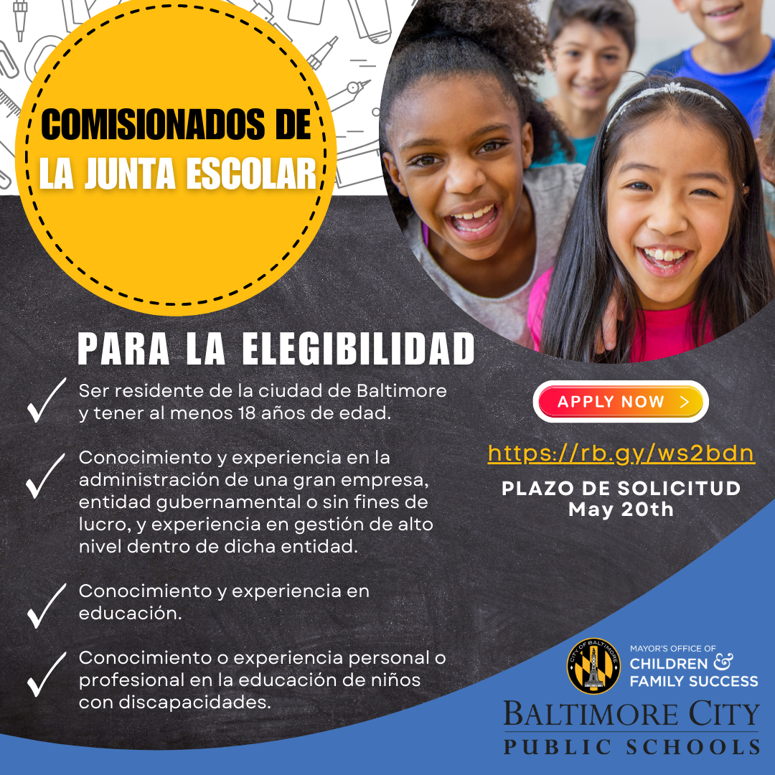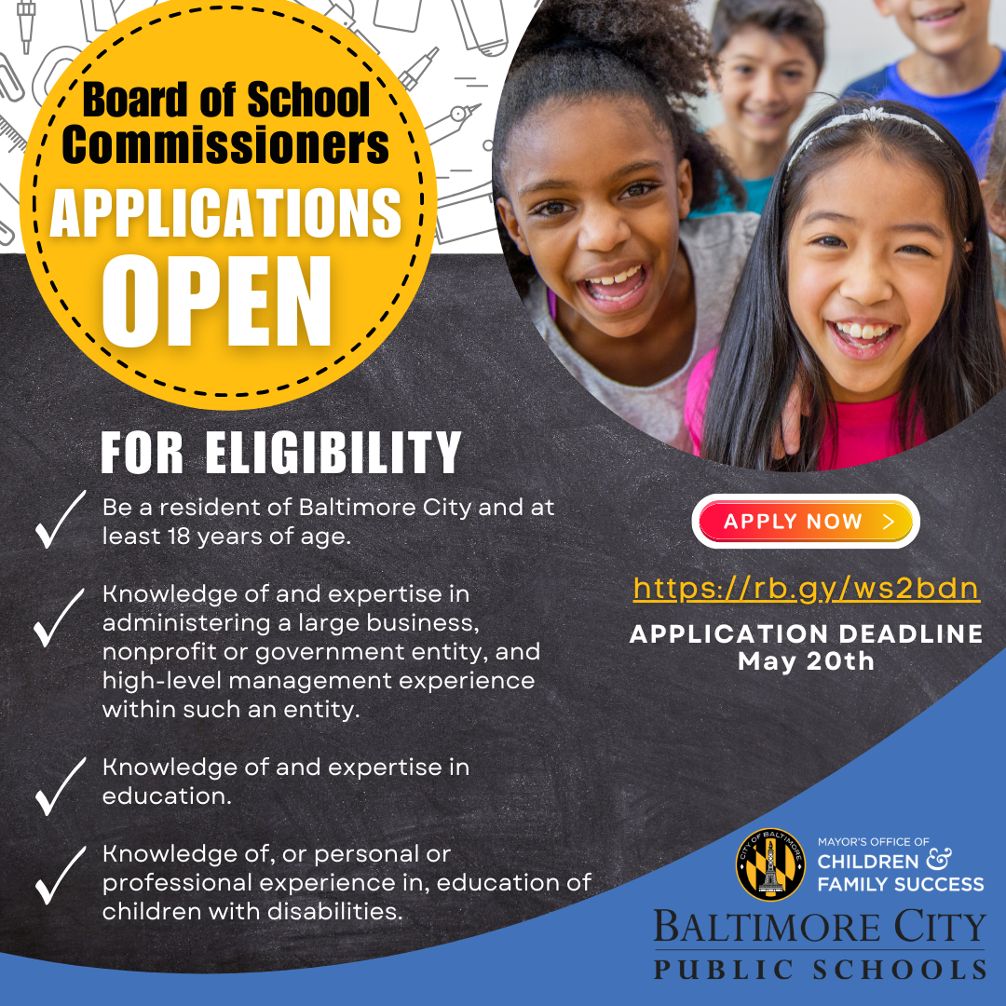

Grant/Scholarship Opportunities
Gates Millennium Scholars Program-Maryland.Gov
The Gates Millennium Scholars (GMS) Program, funded by a grant from the Bill & Melinda Gates Foundation, was established in 1999 to provide outstanding African American, American Indian/Alaska Native, Asian Pacific Islander American, and Hispanic American students with an opportunity to complete an undergraduate college education in any discipline area of interest.

National Happenings
USCIS Announces Open Application Period for the Citizenship and Integration Grant Program
Since 2009, the USCIS Citizenship and Integration Grant Program has awarded $155 million through 644 grants to immigrant-serving organizations. These grant recipients have provided citizenship preparation services to more than 300,000 immigrants in 41 states and the District of Columbia.USCIS expects to award up to 40 organizations up to $300,000 each for two years to expand the availability of high-quality citizenship and integration services. This grant opportunity will fund public or nonprofit organizations that offer both citizenship instruction and naturalization application services to lawful permanent residents. Applications are due by June 21.

Biden-Harris Administration Finalizes Policies to Increase Access to Health Coverage for DACA Recipients-The US Department of Health and Human Services has expanded health care access for Deferred Action for Childhood Arrivals (DACA) recipients. They can now enroll in a Qualified Health Plan (QHP) through the Affordable Care Act (ACA) Health Insurance Marketplace or coverage through a Basic Health Program (BHP). This could benefit up to 100,000 previously uninsured DACA recipients.

EVENTS
Fresh Food Boxes-Baltimore City Department of Recreation and Parks
Don't miss the opportunity to get fresh food boxes for free every Thursday from 12 pm to 4 pm! BCRP is inviting you and your friends to the Plantation Park Heights Urban Farm, located at 3811 Park Heights Ave. This event is open to everyone. Mark your calendars and be sure to check out the event calendar for upcoming BCRP fresh food events!

Summer Camps-BCRP
The end of the school year is swiftly approaching. Camp Baltimore, B’More Summer Fun and a variety of Specialty Camps will be offering summer activities at sites all across Baltimore. For eight weeks children will enjoy fun-filled activities. Explore all camp location and registration
Asia North 2024
Celebrate Baltimore’s Charles North – Station North – neighborhood’s constantly evolving identities as a Koreatown, arts district, and creative hub. The Asian Arts & Culture Center, Central Baltimore Partnership, and many other organizations have worked together to develop a month of thoughtful events and art exhibitions to celebrate AAPI Heritage Month and Baltimore’s AAPI communities. See their full month of events on Towson’s website.

Historic Koreatown & Landmarks with Baltimore Changwon Sister City Committee & Korean American Foundation – Greater Washington

Join Joy Kim for a walking tour of the Charles North neighborhood’s historical Koreatown landmarks and favorite food spots. Presented with the Baltimore Changwon Sister City Committee and Korean American Foundation – Greater Washington.
Date:Saturday, May 18, 2 – 4 p.m.
Location: 16 W North Ave

Children’s Book Art by Japanese American Illustrators

Delight in the imaginative worlds of award-winning children’s book illustrators Melissa Iwai and Katie Yamasaki while learning about courage, love, and adaptation by an incarcerated Japanese American family; intercultural sharing among immigrant families; and multicultural Zen-inspired stories. Become energized to support the welfare of children, intercultural understanding, healing, and peace.
Date: February 7 – May 18 (closed March 17 – 24)
Location: Asian Arts Gallery Corridor Vitrines, Center for the Arts, Towson University

Film Screening: Early Summer (麦秋, Bakushū)

Enjoy this rare screening of a 1951 classic drama from Reed Hessler’s private collection which explores post-World War II social transformation — especially intergenerational conflict, a family’s involvement in a young woman’s (Noriko) decision about marriage, and her will for independence. Directed by Yasujiro Ozu. Hosted by Reed Hessler, a longtime host on WBJC. Co-presented with the Baltimore Kawasaki Sister City Committee (BKSCC) and TU College of Fine Arts and Communication Dean’s Office.
Date: Saturday, May 18, 1 p.m.
Location: Towson University Art Lecture Hall, CA 2032
For more AAPI Heritage Month Events, please refer to this graphic:
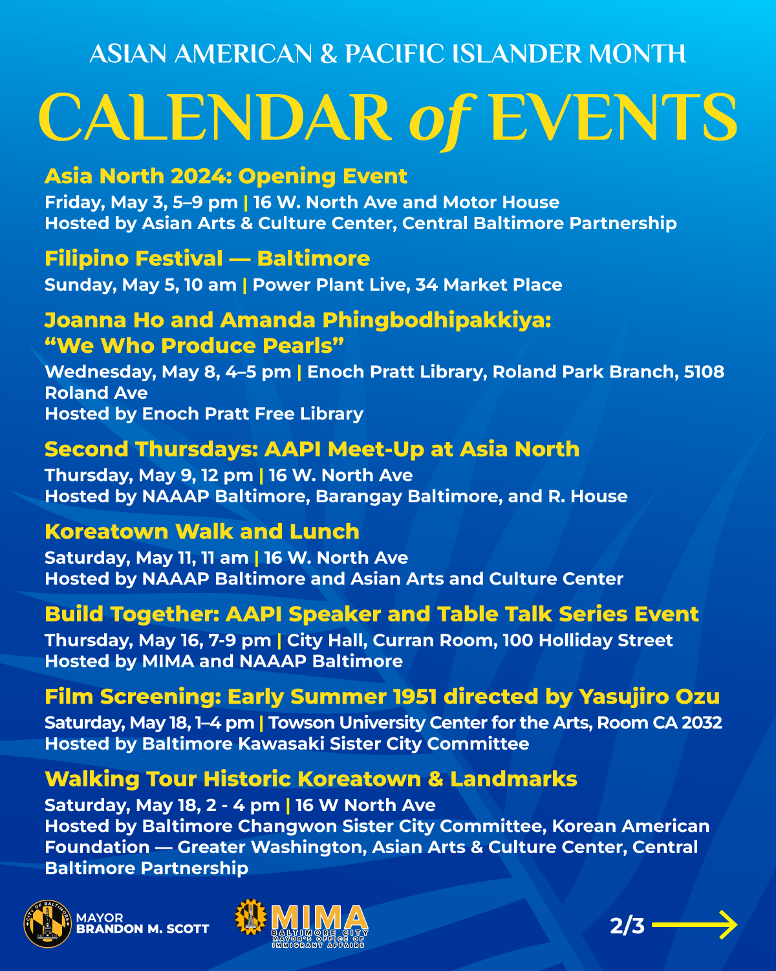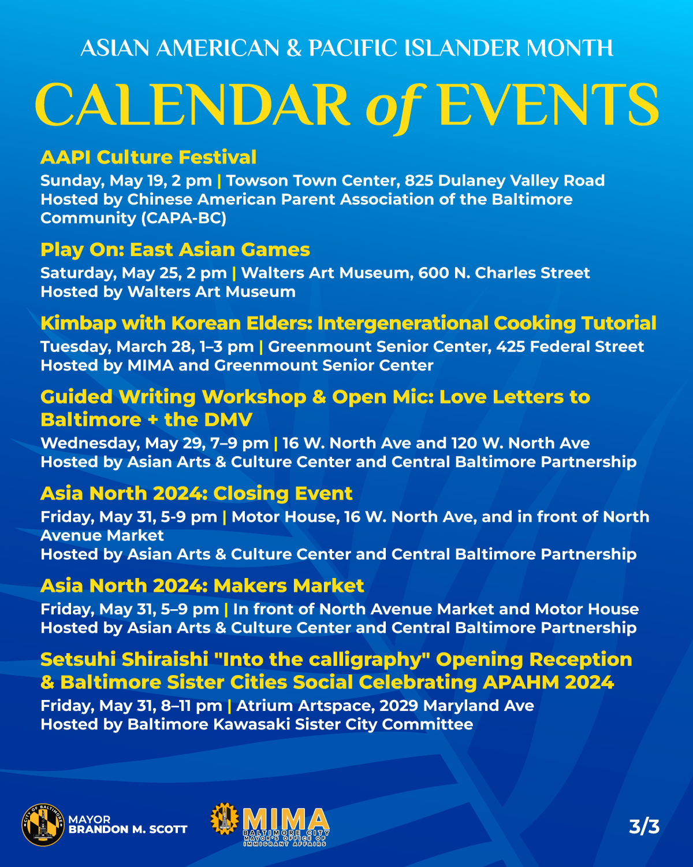

EMPLOYMENT OPPORTUNITIES
Socio-emotional Program Director, United Way of Central Maryland

Family Services Manager,United Way of Central of Maryland

Workplace Development Program Manager, Johns Hopkins Medicine

Director of Workforce Development,Johns Hopkins Medicine In Johns Hopkins Health System

Trainer Officer, Department of Human Services,Learning & Development

Various Openings, Johns Hopkins Medicine

Deputy Director,Operations Officer V, Environmental Control Board

Emergency Services Associate, Mayor’s Office of Homeless Services

Victim Services Supervisor(SAPP)Grant Services Specialist IV(NCS), Patrol & Community Policing Bureau

Basketball Coach, Islamic Leadership Institute

Teacher (Eastern Region), State of Maryland

Bilingual Program Supervisor,Blueprint, Mayor’s Office of Employment Development

Bilingual Career Coach,Blueprint, Grant Service Specialist II -MOED

Bilingual Clinical Assistant, Grant Services Specialist I-Health Department

Operations Officer I,Executive Assistant to Council President

Emergency Dispatcher, Baltimore Police Department

BCIT Summer Internship, Security Operations & Engineering

Traffic Maintenance Worker II, Department of Transportation

Complaint Intake Specialist,Program Compliance Officer I (NCS)- Office of Equity and Civil Rights

Cashier I, Department of Public Works

9-1-1 Operator-Fire Department

Inclusion Assistant Seasonal,Recreation Arts Instructor(NCS)- Baltimore City Recreation and Parks

Case Manager, Virtual Reception and Placement, United States Conference of Catholic Bishops

Manager, Virtual Reception and Placement, United States Conference of Catholic Bishops

Disclaimer: English version of newsletter may be subject to differ from translated versions

Want to stay updated with the latest information and resources for our immigrant and refugee communities?

Follow MIMA on Facebook and Instagram!

To sign up to receive our monthly update via email or suggest announcements to include, please submit this form.

