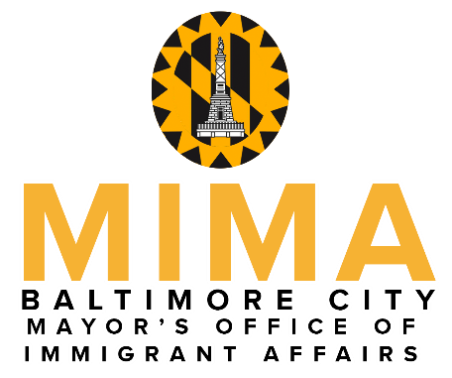

Mayor Bernard C. “Jack” Young

presents

The 2020 Mayor’s Hispanic Heritage Awards
To recognize exemplary individuals who have made outstanding contributions toward improving quality of life within the Hispanic community in Baltimore City, particularly in response to COVID-19

Nomination Guidelines
- Fill out the nomination form below by listing the sponsor, the nominee, nomination category, and the reasons the candidate should be recognized for their work.
- Please note that for the 2020 Hispanic Heritage Awards, the Mayor would like to honor those whose work has been in response to the COVID-19 pandemic in support of the Hispanic community.
- Complete the application online at mima.baltimorecity.gov (preferred) or e-mail this form to mima@baltimorecity.gov.
- Nomination forms MUST BE RECEIVED by Monday, September 28, 2020.

- A selection committee will review all of the nominations.
- Sponsors & winners will be notified by Friday, October 2, 2020.

- Due to COVID-19 and social distancing requirements, the ceremony that will honor the winners in each category will take a different, likely virtual format this year. Details are forthcoming and will be announced via MIMA’s Facebook page.

For more information, contact mima@baltimorecity.gov
Nomination Form

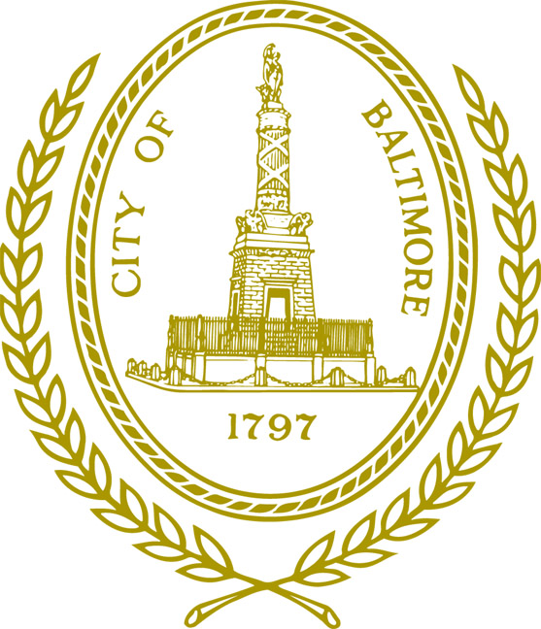
NOMINATOR

Name

Cell Phone Number Alt. Phone Number

Mailing Address for Contact Person Zip Code

Baltimore, MD

E-mail Address

Category (choose only one)

۝ Emerging leader (must be 21 years of age or under)
۝ Educator (works in education or training in the Latino community, any field)
۝ Service Provider (works for a non-profit organization or business that serves the Latino comm.)
۝ Volunteer (works with the Latino community above and beyond their job responsibilities; must be 22 years of age or over)
۝ NEW: The Delfina Haydee Pereda Echeverria Award (for a community member whose work demonstrates the bridge building and compassion of the late Delfina Haydee Pereda Echeverria)

NOMINEE

Name Telephone Number

Mailing Address Zip Code

Baltimore, MD

E-mail Address

FOR EMERGING LEADER, EDUCATOR, SERVICE PROVIDER, or VOLUNTEER: Please provide a description of the nominee’s work in the Latinx community as related to COVID-19. What is the impact of their work? Include brief biographical information. (300-400 words)

FOR THE DELFINA HAYDEE PEREDA ECHEVERRIA AWARD: Please provide a description of the nominee’s work as it relates to building bridges between the Hispanic/Latinx community and other entities or communities in Baltimore City. Their work should be in the spirit of the late Delfina Haydee Pereda Echeverria for whom the award is named. (300-400 words)

Date:

