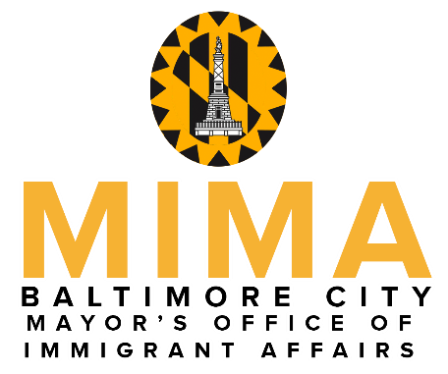

Mayor Catherine E. Pugh

presents

The 2018 Mayor’s Hispanic Heritage Awards
To recognize exemplary Hispanics who have made outstanding contributions toward improving quality of life within the Hispanic community in Baltimore City

Nomination Guidelines
- Fill out the nomination form below by listing the sponsor, the nominee, nomination category, and the reasons the candidate should be recognized for their work.
- Complete the application online at http://mima.baltimorecity.gov (preferred), e-mail this form to hispanic.commission@baltimorecity.gov, OR print & mail to:
Baltimore City Hispanic Commission
Mayor’s Office of Immigrant Affairs
Room 331, City Hall
100 N. Holliday St.
Baltimore, MD 21202
- Nomination forms MUST BE RECEIVED by August 31, 2018.

- A selection committee will review all of the nominations.
- Sponsors & winners will be notified by September 7, 2018.

- The winner in each category and a guest will be invited to join Catherine E. Pugh at the 12th Annual Hispanic Heritage Month Celebration.

For more information, contact hispanic.commission@baltimorecity.gov
Nomination Form

PLEASE PRINT NEATLY

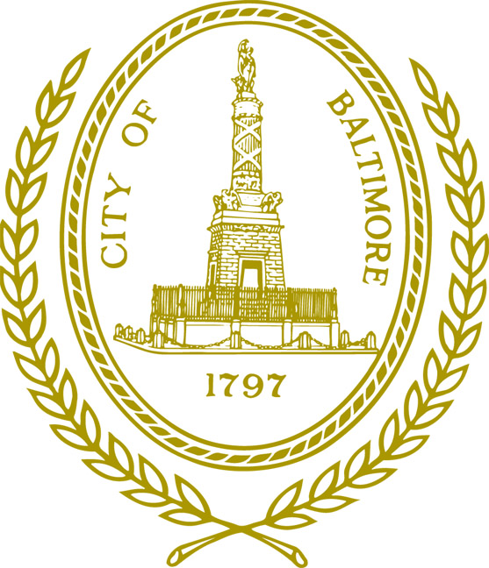
NOMINATOR

Name

Cell Phone Number Alt. Phone Number

Mailing Address for Contact Person Zip Code

Baltimore, MD

E-mail Address

Category (choose only one)

۝ Emerging leader (must be 21 years of age or under)
۝ Educator (works in education or training in the Latino community, any field)
۝ Service Provider (works for a non-profit organization or business that serves the Latino comm.)
۝ Volunteer (works with the Latino community above and beyond their job responsibilities; must be 22 years of age or over)

NOMINEE

Name Telephone Number

Mailing Address Zip Code

Baltimore, MD

E-mail Address

Please provide a description of the nominee’s work in the Latino community. How has the community advanced thanks to her/his contribution? Include brief biographical information. (300-400 words)

Date:

